**Körber**

**Körber** provides a broad range of proven, end-to-end supply chain solutions fitting any business size, strategy, or appetite for growth. Experience the future of supply chain logistics: efficiency, sustainability and end-to-end integration in the virtual Körber World.

German and Jewish (Ashkenazic) (Körber): occupational name for a basket maker from an agent derivative of Middle High German Korp German Korb 'basket'.

Körber provide innovative te**chnological solutions** to help you manage rapid change, optimize your operational capacity, and quickly scale to demand.

Transfer Request is sent here in Koerber. Koerber is referred to as K1.

It is a real time system. It is used to track the inventory on real time basis which helps in (Picking, Packing, loading, shipping and inventory management tasks).

#### Three Environment are there in **Körber: -**

#### ****Prod Environment:** - Available for all Users which supports the day-to-day warehouse activities.****

****

**** [https://slgwaprodweb.koerbercloud.com/core/Default.html A close-up of a white box AI-generated content may be incorrect.](https://slgwaprodweb.koerbercloud.com/core/Default.htmlDev Environment :-URL: https://slgwaconfweb.koerbercloud.com/core/Default.htmlTest Environment :- URL:- https://slgwatestweb.koerbercloud.com/core/Default.htmlEnvironment details:Prod -)

#### [Dev Environment :- URL: https://slgwaconfweb.koerbercloud.com/core/Default.html A close-up of a logo AI-generated content may be incorrect.](https://slgwaprodweb.koerbercloud.com/core/Default.htmlDev Environment :-URL: https://slgwaconfweb.koerbercloud.com/core/Default.htmlTest Environment :- URL:- https://slgwatestweb.koerbercloud.com/core/Default.htmlEnvironment details:Prod -)

#### [Test Environment :- URL:- https://slgwatestweb.koerbercloud.com/core/Default.html A white background with blue text AI-generated content may be incorrect. Environment details: Dev-](https://slgwaprodweb.koerbercloud.com/core/Default.htmlDev Environment :-URL: https://slgwaconfweb.koerbercloud.com/core/Default.htmlTest Environment :- URL:- https://slgwatestweb.koerbercloud.com/core/Default.htmlEnvironment details:Prod -) **[The dev environment is used to designing, creating and deploying all configuration done by the project team, As the project leaves the adapt phase and enters into the validate phase all changes moved up to test environment. So customers can test as changes and issues are identified they are configured in DEV and moved to test.](https://slgwaprodweb.koerbercloud.com/core/Default.htmlDev Environment :-URL: https://slgwaconfweb.koerbercloud.com/core/Default.htmlTest Environment :- URL:- https://slgwatestweb.koerbercloud.com/core/Default.htmlEnvironment details:Prod -)** [Test-](https://slgwaprodweb.koerbercloud.com/core/Default.htmlDev Environment :-URL: https://slgwaconfweb.koerbercloud.com/core/Default.htmlTest Environment :- URL:- https://slgwatestweb.koerbercloud.com/core/Default.htmlEnvironment details:Prod -) **As the project approaches the deploy phase (go-live), the changes in test are moved to Prod and that environment is set up for the end users in the warehouse. When all environments are utilized, changes will be made in Dev moved to test for testing then promoted to prod for the end users to utilize.**Prod- The latest updates are published or pushed to the end users.

**Tools/Applications used in Koerber:**

There are various applications used in Koerber for supporting the day-to-day warehouse activities or bug fixing the issues which we used to receive from the SNOW (service Now backend application) through which we get the Incidents and in RDP servers there are listed Koerber applications by which we can track down the issues or create/modify the pages in Koerber application K1. Below are the listed various applications which is used in K1 app.

**Koerber Webwise Page Editor tool:**

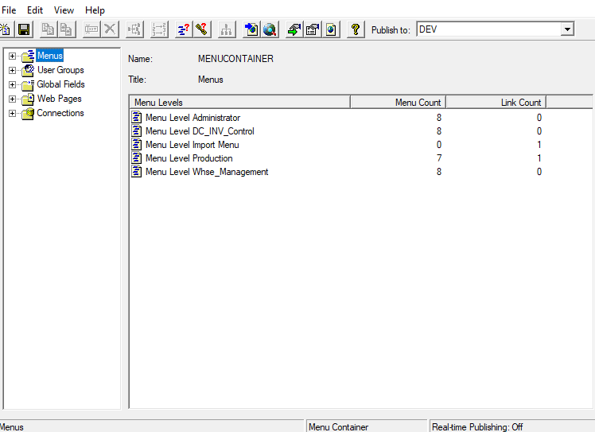

**AWESM: (Advantage workflow engine service Manager)**

**Advantage Virtual Terminal:**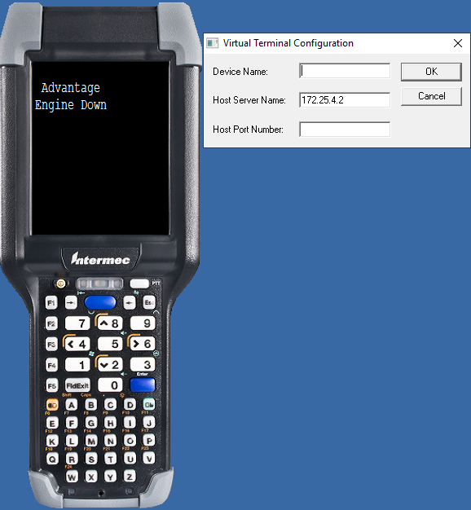

**Koerber Advantage Architect:**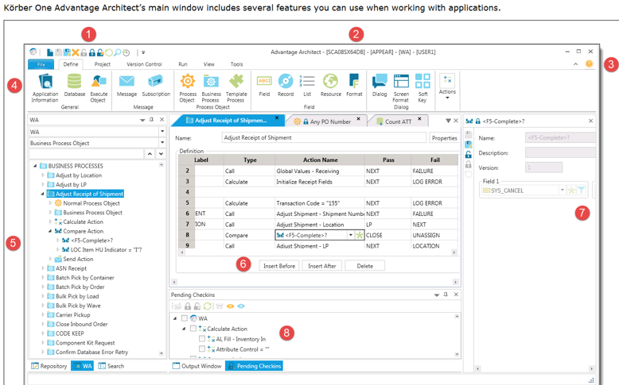

#### ****Overview**** ****1. Körber (K1)****

* Körber, also known as **K1 or High Jump**, is a **real-time Warehouse Management System (WMS)** used for managing inventory, warehouse operations, and logistics.
* **WTS (Warehouse Tracking System)** functions in a **batch processing mode**, meaning it updates inventory and orders in cycles rather than in real time.
* The two systems operate independently, leading to synchronization challenges and **potential duplication of inventory tracking**.
* Körber includes a **web UI for warehouse staff** to build loads, manage inventory, and research orders.

**WMS (Warehouse Management System)**

* **Purpose**:

A WMS is a comprehensive software solution designed to manage and optimize all aspects of warehouse operations, from receiving to shipping.

* **Key Features:**
  + Inventory management (tracking stock levels, bin locations, etc.).
  + Order fulfillment (picking, packing, and shipping).
  + Labor management (assigning tasks to workers).
  + Reporting and analytics (providing insights into warehouse performance).
  + Integration with other systems like ERP (Enterprise Resource Planning) or TMS (Transportation Management System).
* **Use Cases:**
  + Automating and streamlining warehouse processes.
  + Optimizing storage space and inventory placement.
  + Improving order accuracy and reducing delivery times.
  + Managing complex warehouse operations for large-scale businesses.

**WTS (Warehouse Technology System)**

* **Purpose**: WTS is primarily focused on **tracking and monitoring** the movement of goods, inventory, and assets within a warehouse or distribution center.
* **Key Features:**
  + Real-time tracking of inventory using technologies like **barcodes and RFID (Radio Frequency Identification and data capture system), or GPS**.
  + Provides visibility into the location of items within the warehouse.
  + Often integrates with other systems (e.g., WMS) to provide accurate tracking data.
  + Helps in reducing errors, improving efficiency, and ensuring accountability.
* **Use Cases:**
  + Tracking the exact location of a specific pallet or item.
  + Monitoring the movement of goods from receiving to shipping.
  + Ensuring inventory accuracy and reducing loss or misplacement.

#### ****2. Inventory and Order Management:****

* **Browse Track prevents over commitment to inventory** when processing transfer requests.
* **Körber interacts with multiple warehouse systems** (FCS, DCS, SV2/ESL), while WTS operates separately, leading to inconsistencies.
* **Glass track serves as a middle layer**, communicating inventory sourcing requests between Körber and WTS.
* **Orders and inventory updates must sync** between Körber, WTS, and EBS (Enterprise Business System), but timing issues cause **data mismatches**.
* **Load Building & Processing Order: -**
* Users create loads via the **web UI (AFA Configure)**, assigning them pack locations, staging lanes, and doors.
* Loads are named based on ship-to names, including stop IDs, which are commonly referenced in incident tickets.
* **Orders are added based on ship-to codes**, and waves are created based on inventory types of the orders.
* If inventory is available, it moves to **OWL allocation (Order Warehouse Location)**; if not, it goes to the **missing allocation** section where staff can short the order.
* **ASM receiving** is available against inbound orders on the inbound side, allowing receipt directly against the inbound order.

#### ****3. Operational Challenges and Support:****

* **Körber requires constant support**, with **4-5 dedicated associates managing issues and project work**.
* The **implementation of Körber was incomplete**, leading to inefficiencies and workflow mismatches.
* Frequent **system outages (often unplanned by Körber Cloud)** disrupt warehouse operations.
* **Middleware issues (like Mulesoft delays) cause order processing failures** and missing inventory data.
* **Data discrepancies** between Körber, WTS, and Glashtrack require **manual intervention** for resolution.
* **Warehouse Operations & Picking: -**
* Pickers use the **RF Emulator** to pick and sort inventory.
* The system assigns tasks based on warehouse, user ID, and equipment (e.g., forklift or manual cart picking).
* Orders are picked based on inventory type (e.g., accessories like wiper blades).
* If a **partial pick occurs**, remaining work is created for another user to complete the pick.
* Once picked, items are deposited in a **pack location**, and pickup work is created for outbound staging.
* Items move from staging to loading, where workers **scan the LP, enter the trailer number, and scan the door** before completing the load.
* Once everything is picked up and loaded, clicking **"Ship Load" triggers the shipment confirmation.**
* **QC and Clean Process**: Items like windshields, which require inspection, are directed to a QC and Clean location instead of a pack location. The item is audited and cleaned before being moved to outbound staging.
* **Manual Move Options**: Users can manually move inventory from one storage location to another if needed.
* **Directed Pickup**: Used to create pickup work queues, including replenishment and staging pickups.
* **Cycle Counting and Hold Management**: Inventory can be placed on hold or released from hold through cycle counting operations.
* **Printing LPs**: Workers use the system to print LPs from the RF for wave picking.

#### ****4. Transition from WTS to Körber:****

* Moving a warehouse from **WTS to Körber requires careful coordination** to avoid duplicate orders and inventory mismatches.
* **Once a warehouse transitions to Körber, it rarely reverts to WTS**, with only replenishment orders moving between them.
* **Körber lacks a built-in Order Management System (OMS)**, requiring external tools for sourcing and allocation.

#### ****5. System Interactions and Troubleshooting:****

#### ****Körber is the primary system of record for inventory****, but it must sync with Glass track and EBS for accuracy.

#### ****Common issues include:****

* Mismatches in inventory counts (e.g., Körber shows 11, while Glashtrack shows 10).
* ASN (Advanced Shipping Notice) and PO (Purchase Order) data failing to sync.
* Users unable to receive items in Körber or SV2 due to missing system updates.
* **Support teams must track issues across multiple systems**, often escalating major outages to **Körber Global Support**.
* **Page Editor and Development Tools:**
* Page Editor is used for configuring search pages and defining parameters for reports.
* Developers troubleshoot queries using Page Editor’s SQL execution page.
* Pages are identified by numbers, which can be accessed via the web server.
* The **Visual Debugger** is used to troubleshoot RF device errors by connecting to the application server and running message watches.
* **Access to Körber’s system is through Corporate Cloud** and requires user credentials managed through Remote Desktop Manager.

#### ****Körber’s Evolution and Future Considerations:****

* **Previously known as "High Jump,"** Körber has undergone several ownership and branding changes.
* **Standardizing Körber processes across warehouses** is a long-term goal for smoother operations.
* More warehouses are migrating to Körber, increasing the need for **better real-time data integration** between systems.
* Future improvements should focus on **reducing system downtime, improving middleware efficiency, and automating inventory reconciliation**.

### **Glass Track Summary**

#### ****Overview****

Glass Track is a critical system in the supply chain responsible for managing inventory transfers, tracking demand, and sourcing materials efficiently. It ensures the correct parts are allocated and transferred in a timely manner, playing a key role in order fulfillment.  
  
**Environments in Glass Track:**

Glass Track has 5 environments namely below -

(Dev, Sys, QA, Train, and Production) but we are only using 3 actively, Dev, Sys, and Production.

**Prod :**

<https://glasstrack.safelite.net/#/Buyout/BuyoutDashboard>

**sys:**  
  
<https://glasstrack-sys.safelite.net/#/Buyout/BuyoutDashboard>

**dev:**

For dev currently we do not have access of this once will get then update the below screenshot.  
  
https://glasstrack-dev.safelite.net/#/Buyout/BuyoutDashboard

### **Key Functions of Glass Track:**

#### ****Managing Shorts & Demand:****

* A **short** occurs when the expected inventory is missing from a location.
* Glass Track flags this as demand and adds it to the **buyout list**.
* Associates prioritize buyouts to ensure fulfillment as soon as possible.
* If internal inventory is unavailable, a **vendor buyout** is initiated.

#### ****Buyout Process:****

* Glass Track initiates **transfer requests** for missing items.
* The buyout list helps associates track expected delivery dates and responsible parties.
* The system provides **real-time tracking** of pending and received buyouts.

#### ****Order & Transfer Processing:****

* Each **work order** consists of a work order header and multiple order lines.
* When sourcing parts, **transfer orders (TOs)** are generated.
* A **transfer order (TO)** is linked to a **purchase order (PO)**, even for internal warehouse purchases.
* Example: A warehouse might "buy" glass for $200 internally or from a vendor for $290 (average variance of $90).

### **System Integrations & Data Flow**

#### ****Key Integrated Systems:****

1. **EBS (Enterprise Business Suite - Oracle):**

* The financial system that aligns TOs and POs.
* Tracks demand, financial, and inventory levels.
* Receives nightly inventory updates from various systems.

1. **ESL (Enterprise Supply Logistics):**

* Tracks transfer requests and shipments.
* Glass Track updates ESL on shipment status for receiving purposes.

1. **Gains (Forecasting & Planning System):**

* Receives demand and inventory data from EBS every night.
* Runs a 4–5-hour batch process to generate demand forecasts.
* Output order suggestions requiring financial approval in EBS.

1. **SV2 (Store Interface):**

* Tracks work orders, inventory verification, and transfers.

1. **WMS/WTS (Warehouse Management Systems):**

* Legacy warehouse systems are being phased out in favor of corporate inventory tracking.
* Historically, WTS did not update inventory in real-time, leading to inefficiencies.

### **Order Fulfillment & Vendor Coordination:**

* Once order suggestions are reviewed and approved in EBS, **purchase orders (POs)** are issued.
* **Ruan** is a logistics vendor responsible for transporting glass from suppliers to warehouses.
* Direct vendor shipments are used for urgent orders but are more expensive.

### **Handling Inventory Discrepancies (Shorts):**

* **Shortage Issues:** If an item is recorded as available but missing or damaged, it causes fulfillment issues.
* **Correction Process:** Employees use RF scanners to mark an item as a **technical short**, updating records.

### **Glass Track’s Core Functionality:**

#### ****Key Responsibilities**:**

1. **Inventory Awareness:** Tracks inventory across all locations and identifies necessary transfers.
2. **Work Order Line Processing:** Evaluates availability and allocates inventory.
3. **Transfer Requests:** Initiates requests when inventory is available.
4. **Buyout Box Mechanism:** If required glass is unavailable, initiates a buyout process.
5. **Vendor Orders:** Places vendor buyouts when necessary.

#### ****Technology & Challenges:****

* **Glass Track UI is built on AngularJS, which is considered outdated.**
* **No manual UI for updating inventory; all updates come through system-generated feeds.**
* **Integration with Korber ensures logistics execution and scheduling.**

### **Overall Impact of Glass Track**

* Ensures **just-in-time inventory availability** and minimizes order fulfillment disruptions.
* Helps **identify rare windshields** for customers and ensure real-time tracking.
* A **critical part of the supply chain**, ensuring smooth order processing and inventory allocation.

Future migrations to **Oracle Fusion and phasing out WTS** will streamline

**SV2: Homegrown Work Order Management System**

SV2 is a proprietary, homegrown system designed for store associates to input and manage work orders efficiently. Built as an AngularJS application, SV2 serves as the primary interface that store employees use to interact with the system.

**How SV2 Works**

SV2 operates as a user interface (UI) layer that sits on top of the Enterprise Service Layer (ESL). It enables store associates to process work orders either at the store counter via an in-store computer or through online submissions from Safelite.com.

* Store associates use **SV2** to process work orders either at an in-store computer or online via **Safelite.com**.
* SV2 does not operate independently, it **retrieves data from ESL** and updates store associate’s in real-time.
* SV2 depends on ESL for **work order updates**, **inventory management**, and **order status tracking**.

**Integration with ESL and CSL**

* **ESL (Enterprise Service Layer)**: Handles core business logic and data processing. SV2 primarily retrieves updates from ESL but does not operate independently of it.
* **CSL (Core Service Layer)**: Communicates with ESL and other backend services, ensuring seamless data flow between different enterprise systems.

**SV2's Role in the Workflow**

1. A work order is created either in the store (via SV2) or online (via Safelite.com).
2. SV2 submits the order to ESL, which manages the transaction and inventory details.
3. SV2 continuously pulls updates from ESL, ensuring store associates have real-time information.

While SV2 is dependent on ESL for data, ESL itself functions independently, managing store inventory and business processes at an enterprise level.

This streamlined integration ensures that store associates have a responsive and efficient system to manage work orders while maintaining centralized data consistency across the enterprise.

**SV2 & ESL: Work Order Management System Overview**

**SV2 –** Store Associate Interface for Work Orders

SV2 is a **homegrown, AngularJS-based** system designed to help store associates’ **input and manage work orders** efficiently. It serves as a **UI layer** that interacts with the **Enterprise Service Layer (ESL)** and communicates with the **Core Service Layer (CSL)**.

**ESL – Enterprise Service Layer (Work Order Management System)**

ESL is an **old .NET-based, homegrown system** that serves as the **primary work order management system**. It is responsible for handling work orders, inventory tracking, and transfer requests across the enterprise.

**Key Functions of ESL:**

* **Processes Work Orders:** Once a work order is created in **SV2**, it is sent to ESL, where it **runs through business logic** and tracks inventory demand.
* **Manages Inventory & Transfers:** ESL monitors stock levels and **communicates with WTS (Warehouse Tracking System)** to check product availability.
* **Integrates with External Systems:**
  + **WTS (Warehouse Tracking System)**: ESL sends orders to WTS, which determines if stock is available.
  + **Glass Track**: If WTS cannot fulfill an order, ESL forwards a request to Glass Track for further processing.

**System Workflow Overview**

1. **Work Order Creation**: A work order is submitted via **SV2** (in-store or online).
2. **ESL Processing**: The order is received by **ESL**, which runs business logic and determines demand.
3. **Inventory Check**: ESL communicates with **WTS** to confirm stock availability.
4. **Escalation to Glass Track**: If WTS cannot fulfill the request, the order is forwarded to **Glass Track**.
5. **Order Completion**: Once inventory is confirmed, ESL updates the status, which is reflected in **SV2**.

**SV2 vs. ESL – Key Differences**

| **Feature** | **SV2** | **ESL** |
| --- | --- | --- |
| **Purpose** | User interface for store associates | Work order & inventory management system |
| **Technology** | AngularJS | .NET (homegrown) |
| **Dependency** | Depends on ESL for data | Functions independently |
| **Function** | Inputs & tracks work orders | Manages business logic, inventory, & transfers |
|  |  |  |
|  |  |  |

ESL is a **large-scale enterprise system** that supports multiple products, while **SV2 is primarily a front-end interface** that interacts with it. Together, they ensure a seamless workflow for work order management and inventory tracking.

**Ruan: Vendor Order & Delivery Process**

**Who is Ruan?**

Ruan is a **logistics vendor** responsible for handling **vendor orders and deliveries** to our warehouses. Unlike traditional **vendor buyouts on demand**, Ruan operates as an **intermediary** to optimize the process of getting glass to our warehouses at a lower cost than purchasing directly from the vendor.

**How the Ruan Process Works:**

1. **Order Issuance**:
   * A request is made for glass replenishment.
   * The order is sent to **Ruan**, instructing them to fulfill and deliver it.
2. **Transportation & Delivery**:
   * Ruan **physically loads the glass onto trucks** and transports it to our warehouses.
   * This structured approach ensures efficiency in deliveries while minimizing costs.
3. **Cost Efficiency**:
   * We pay **Ruan** a **much lower price** than directly purchasing from a vendor.
   * This model allows **better cost control** and **optimized inventory replenishment**.

**Ruan’s Role in Inventory Planning:**

* **Long-Term Planning**: Ruan provides **suggested replenishment schedules** (e.g., "replenish this glass in six months").
* **Delayed Inventory Recognition**:
  + Inventory is **not counted as "in stock"** until it physically arrives at the warehouse.
  + Even though Ruan receives shipment instructions months in advance, the stock is not recognized in our system until delivery is confirmed.

**Challenges & Gaps in Integration:**

One major challenge is **integrating Ruan into our inventory system**. Since **Ruan manages shipments independently**, we currently **lack real-time visibility** into:  
1. When vendors **provision** the glass  
2. When Ruan **physically ships** the order

**EBS: (Enterprise Business Suite) – It is an oracle Product**

EBS is a batch system, so even though Corber sends it to EPS instantly, it just gets queued up every 15 minutes.

Inventory Management, you can improve inventory visibility, reduce inventory levels and manage facility operations efficiently.

EBS inventory management is a powerful tool for optimizing inventory levels, reducing costs, and improving customer service.

All your material in each line of business and stage of the inventory lifecycle can be tracked in a single, unified system.

Carefully combining ease-of-use with sophisticated and broad functionality,

Inventory Management supports organizations with basic materials management needs as well as those with highly complex and automated requirements.

• Proactively monitor facility operations and inventory levels

• Effectively manage the flow of goods into and out of the facility

• Support discrete inventory, process inventory, and spare parts in a single solution

• Track global inventory balances and transact in dual units of measure

• Optionally deploy to distributed execution systems, such as distributed warehouse management systems or third-party logistics providers

• Track product genealogy and transaction history

• Restrict material transactions using user defined status controls against locations, lots, serials, and on-hand

• Flexibly define, capture and maintain lot and serial attributes

**GAINS:**

In the Korber inventory management system, "GAINS" stands for "Global Availability and Inventory Network System,"

essentially referring to a software feature that provides comprehensive visibility into inventory levels across all locations within a supply chain,

allowing for optimized inventory distribution and informed decision-making based on real-time data about stock levels and movements.

**Real-time visibility:**

It gives users access to detailed inventory data down to individual SKUs (Stock Keeping Units) across different warehouse locations.

**Inventory optimization:**

By providing a holistic view of stock levels, GAINS facilitates better planning and management of inventory to avoid stock outs and minimize excess stock.

**Supply chain coordination:**

This system enables improved coordination between different parts of the supply chain by allowing for real-time tracking of inventory movements.